Kana,

I’ve made some modifications to the pages. I will try to guide you through them. Let me know if you have any questions.

Admin Page-  
Starting with the “Admin Page” I have replaced the “New Instrument/Class” button with a separate button for each. Then I added a button for “New Announcement” and moved the “Announcements” button to the “Lists” column.



Add Class Orange.jpg classes orange.jpg

add instrument orange.jpg instruments orange.jpg

New Announcement.jpg announcements orange.jpg

Add Class Page-

When the “Add Class” button on Admin page is clicked it would bring you here to create the new class. The class could be created from a saved template or from square one (blank). When the new class is submitted, then the class will appear on the “Class List” page. There will be an option to “Save as Template”, which will automatically add the class to the list of available templates. (I did not take the time to create the actual buttons.)



Add Class

Create from Saved Templates   
(selecting this choice will bring up list of saved class templates where perhaps the only modification would be the new dates)

Or

Create New  
(selecting this choice would require all listed fields to be entered)

Class Name: _____________________________________

Meeting Day/s : __________________________________  
  
Dates: _________________________________________

Class Time : ______________________________________

|  |
| --- |
| Submit |

|  |
| --- |
| Save as Template |

“Add Instrument” Page-

When the “Add Instrument” button on Admin page is clicked it would bring you here to add the instrument. When the new instrument is submitted, then the name of the instrument would appear on the “Instrument List” page.

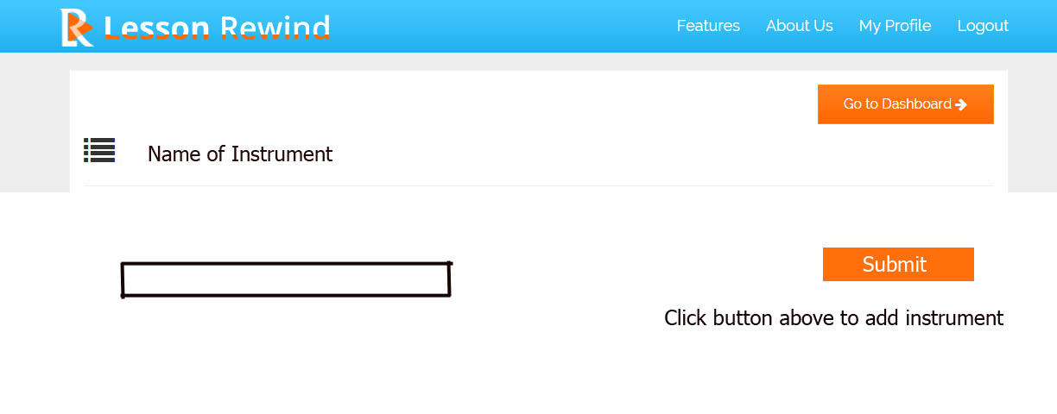

“Class List” Page-

All classes should be listed here once they have been submitted from the “Add Class” page. When a student registers for a class the student count should increase by one. When a student withdraws from a class the student count should decrease by one. Clicking on the class name such as “Drama 101” should bring up the class roster with all of the students listed.

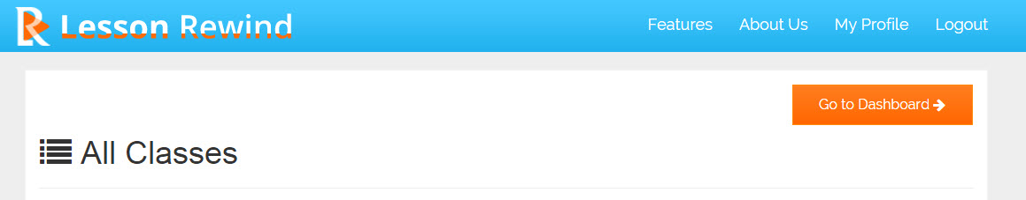

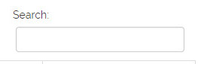

|  |  |  |  |  |  |  |  |
| --- | --- | --- | --- | --- | --- | --- | --- |
| S.NO | Class | Days | Dates | Time | Student Count | Edit | Delete |
| 1 | Drama 101 | Tuesdays and Thursdays | Jan 6 – Jan 29 | 1:00 – 2:00 | 15 | edit picture.jpg | trash can.jpg |
| 2 | Drama 202 | Mondays and Wednesdays | Jan 5 – Jan 28 | 2:00 – 3:00 | 12 | edit picture.jpg | trash can.jpg |
| 3 | Guitar Basics | Mondays | May 4 – July 27 | 5:10 – 5:55 | 6 | edit picture.jpg | trash can.jpg |
| 4 | Guitar Basics | Fridays | May 8 – July 31 | 4:10 – 4:55 | 3 | edit picture.jpg | trash can.jpg |

“Instrument List” Page-

All instruments will be listed here once they have are added from the “Add Instrument” page. The student count increases when a student registers for that instrument or decreases when he drops. The teacher count increases when a teacher is added for teaching that instrument or decreases when a teacher quits. Clicking on the instrument name “Guitar” should bring up a new page with a list of students registered for that instrument.

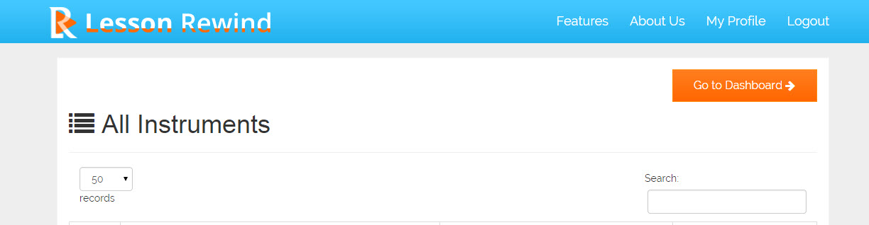

|  |  |  |  |  |  |
| --- | --- | --- | --- | --- | --- |
| S.NO | Instrument | Student Count | Teacher Count | Edit | Delete |
| 1 | Guitar | 32 | 2 | edit picture.jpg | trash can.jpg |
| 2 | Piano | 66 | 4 | edit picture.jpg | trash can.jpg |